SCIENCE
SKILLS TEST

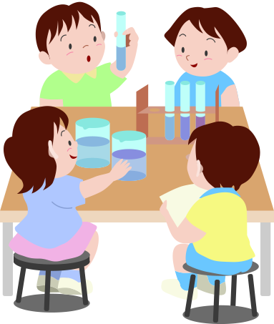

Name:______________

SCIENCE SKILLS – self assessment

Lesson | Learning outcome I can…
Safety | - Come up with 5 class safety rules.  - Give ideas to make things safe  - Identify hazard symbols | ☺😐☹
Equipment | - Recall the names of different pieces of equipment  - Suggest what each piece of equipment is used for  - Select appropriate equipment for a task  - Demonstrate careful measurements using a equipment | ☺😐☹
Observing | - Use several senses (hearing, sight, touch) to make observations.  - Use scientific words to communicate my observations.  - Imagine what the experiment was like, given the observation notes. | ☺😐☹

Q1. Identify the following lab apparatus: (4)

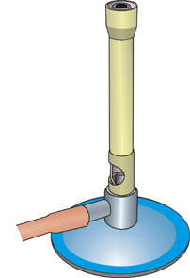
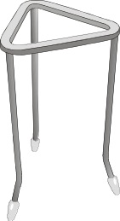
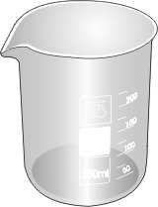
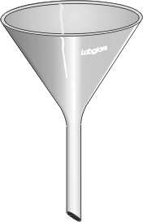

Q2. Match the following symbol drawings to their correct name (4)



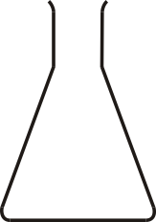
Evaporating Dish
Gauze
Test tube rack
Conical Flask

Q3. Name the apparatus used in science to measure; (4)

Temperature ___________________
Mass ___________________
Length ___________________
Volume ___________________

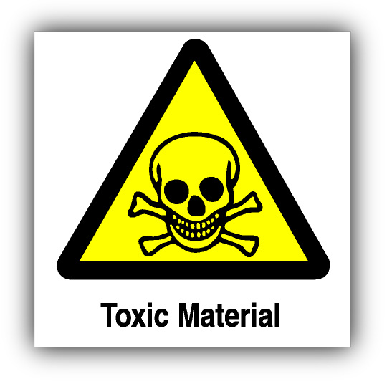
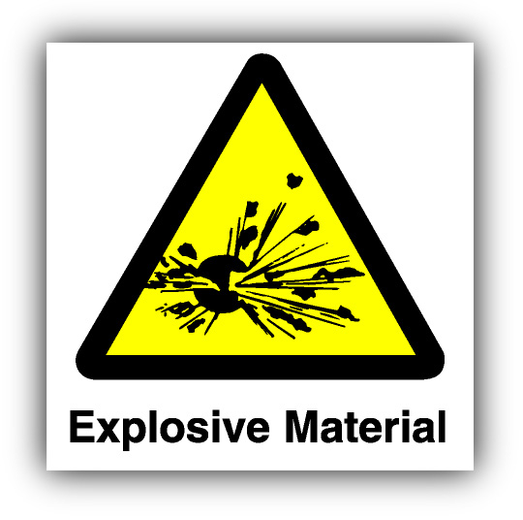
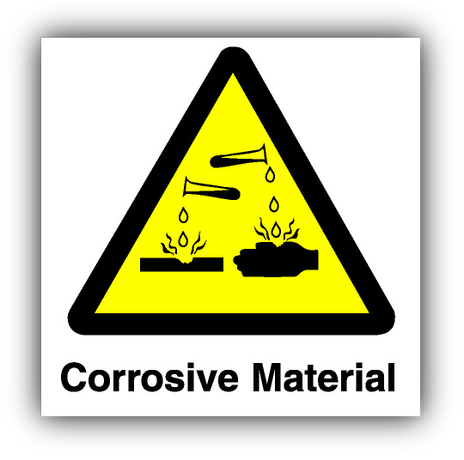
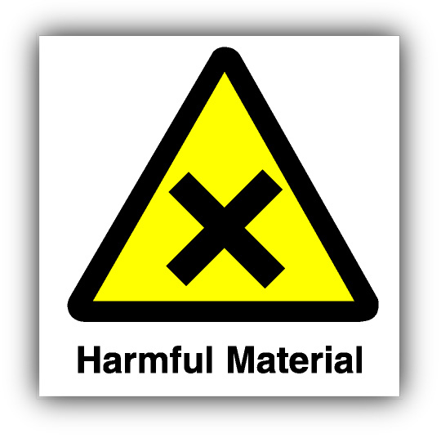
Q4. Identify the following safety symbols: (4)

i

Q5. Choose any other safety sign that we have studied and draw a picture of it below. (Colour it in) (2)

Q6. Convert these measurements: (10)

- 1.7Kg = g
- 10cm = mm
- 1000ml = l
- 500g = Kg
- 180mm = cm
- 1.8l = ml
- 1.5 mins = s
- 96s = mins
- 1000cm³ = l
- 44cm = km
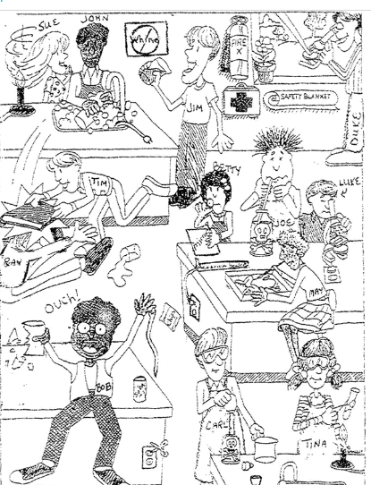
Q7. List six safety problems you can see in this picture. (6)

1. ___________________________
2.___________________________

3.___________________________

4.___________________________

5.___________________________

6.___________________________

Q8. Read the rulers below: (4)
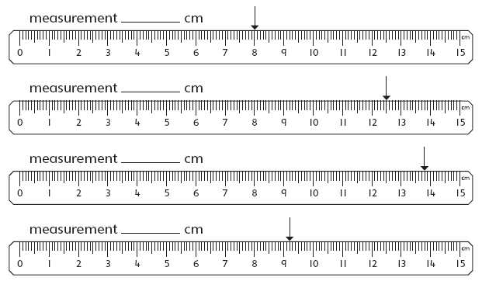

Q9. (7)
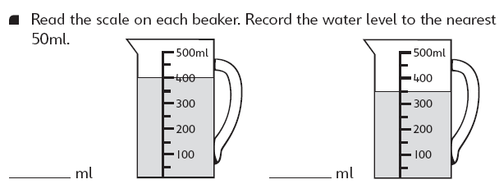
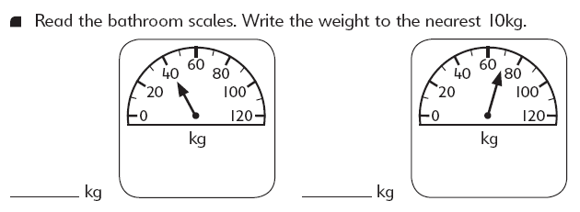

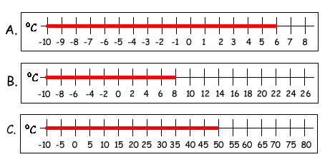

Q10. Circle the correct answer. (4)


