Shenley Academy



Moving from Primary to Secondary School is an exciting, but sometimes scary time! A new building, new rules, new teachers, new routines and new friends are just some of the changes you will experience but this booklet will help you get used to some of the routines and features of your new school!

Do not forget to bring your completed

workbooks when you start in September!



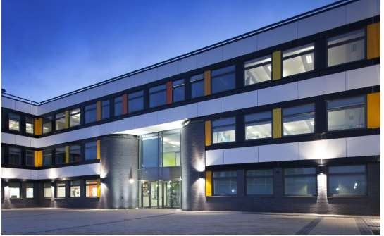



Name:

Draw a self-portrait here.

Birthday:

My Primary School:

Eye Colour:

Hair Colour:

Height:

|  |  |
| --- | --- |
| **Favourite Colour** |  |
| **Favourite Animal** |  |
| **If I could have a**  **superpower, I’d….** |  |
| **Favourite School Subject** |  |
| **Best place I’ve ever been to…** |  |
| **Dream country to visit…** |  |
| **If I could travel back in**  **time, I’d go to…** |  |
| **My dream job is…** |  |





Life is a journey! Think back through primary school and write down your favourite

memories or events that have shaped you to become the amazing person you are!



|  |  |
| --- | --- |
| **Full Name of the School** |  |
| **School Address** |  |
| **School Telephone**  **Number** |  |
| **Name of the Head**  **Teacher** |  |
| **School Starts at** |  |
| **School Finishes at** |  |
| **I will get to school by** |  |
| **How long will it take you**  **to get to school?** |  |
| **What time will you have to leave home?** |  |

*Add 10 words around the image below to describe your new school .*





* List 4 things you are most excited about moving to Shenley

Academy:

1.

2.

3.

4.

* List 4 things you are a little worried/nervous about: 1.

2.

3.

4.

* List 4 things you would like to know about Shenley Academy: 1.

2.

3.

* List 4 things that will help you when moving to Shenley Academy: 1.

2.

3.

4.

* List 4 differences between your primary school and Shenley

Academy:

1.

2.

3.

4.



Find the subjects below in the Word search – they are vertical, horizontal and diagonal!

|  |  |  |  |  |  |  |  |  |  |  |  |  |  |  |  |  |
| --- | --- | --- | --- | --- | --- | --- | --- | --- | --- | --- | --- | --- | --- | --- | --- | --- |
| M | A | F | S | E | H | M | G | E | O | H | I | M | J | E | E | A |
| F | M | A | M | W | S | L | U | S | M | I | S | E | T | T | I | S |
| R | U | D | A | N | C | E | Z | S | A | C | P | N | U | H | A | I |
| A | F | G | T | R | D | P | W | R | I | I | A | G | T | I | N | U |
| H | S | R | H | P | G | R | T | E | N | C | I | T | O | C | A | O |
| J | T | A | S | L | U | B | N | Y | R | A | N | E | R | S | S | L |
| T | U | B | J | E | I | C | Q | L | E | R | M | X | T | A | S | S |
| E | E | A | U | H | E | M | U | A | H | S | U | D | I | N | E | P |
| N | F | X | L | G | E | O | G | R | A | P | H | Y | M | D | M | A |
| G | I | M | T | V | M | A | I | T | Y | E | O | A | E | M | B | N |
| L | O | A | I | I | O | T | O | H | R | T | T | S | C | O | L | I |
| I | P | T | E | E | L | G | R | D | U | O | E | R | A | R | Y | S |
| S | P | U | F | O | S | E | E | K | R | M | P | T | T | A | E | H |
| H | I | S | T | O | R | Y | S | C | S | A | S | M | E | L | R | A |
| E | N | J | V | E | P | I | F | J | N | O | M | U | R | S | B | K |
| J | K | C | A | T | E | R | I | N | G | C | N | A | R | P | U | M |
| Y | Z | X | T | L | S | V | Z | C | O | M | P | U | T | I | N | G |

# Maths English Science Geography History

Art Music PE

# Drama

Dance Textiles Catering Computing

# Ethics and Morals Spanish Assembly Tutor Time



**Match up the subject to the correct icon**



# https://static.thenounproject.com/png/253716-200.pnghttps://static.thenounproject.com/png/3148531-200.pnghttps://static.thenounproject.com/png/214897-200.pngMaths English Science Geography History

Art Music PE



# https://static.thenounproject.com/png/715001-200.pnghttps://static.thenounproject.com/png/3249581-200.pnghttps://static.thenounproject.com/png/1176750-200.pngDrama Dance Textiles Catering Computing

Ethics and Morals Spanish

# Tutor Time



At secondary school, you will be moving around to different classrooms for different lessons. You could be in 7 classrooms in one day. This means that you need to bring all the equipment you will require with you for the day.

Below are some items you will need to bring – can you identify them and

add anything else?





https://static.thenounproject.com/png/1753102-200.png

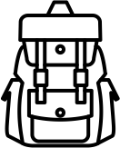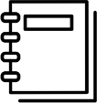



One of the different things about moving to secondary school is the change in what you will wear. At Shenley Academy we pride ourselves in looking smart and professional at all times. Use the school website or the information booklet to draw and label the school uniform you will wear onto the Lego figure

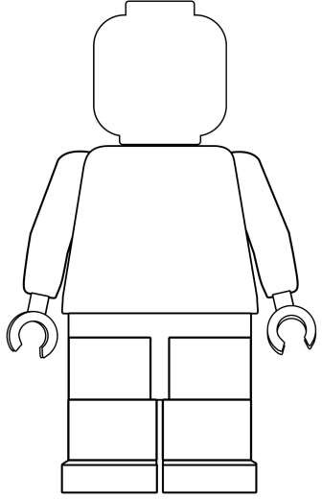

Why is wearing the correct school uniform important?

……………………………………………………………………………………

……………………………………………………………………………………

……………………………………………………………………………………

……………………………………………………………………………………

……………………………………………………………………………………



Getting to Shenley Academy safely is just as important as being there. In the box below, draw the route you are going to take to school (whether that’s walking, cycling, driving or by bus). Identify spots where there could be hazards (e.g. busy roads) and explain how you will manage this safely!



When you go to Secondary School, you will learn a huge number of new skills, and improve skills you have practiced in Primary School. In the goal below, use the list to write in 10 new skills or

things you’d like to build on in your years at Secondary School.

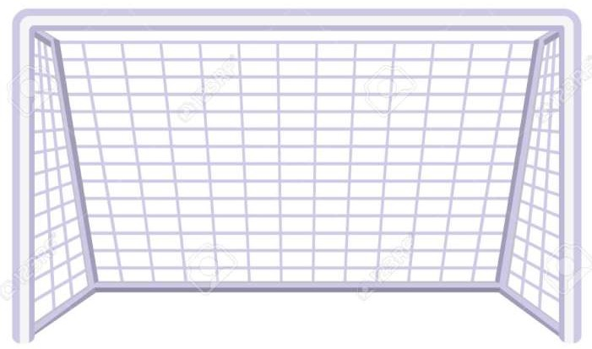

|  |  |  |
| --- | --- | --- |
| Be in a school play or  production | Speak another language | Represent your school in a  national competition |
| Learn to play a musical instrument | Volunteer in the local community | Travel to another country |
| Play for a school team | Learn how to survive in the  wild | Take care of the school  garden |
| Learn how to manage money | Taste food from another country | Walk the school dog |
| Cook a new meal from  scratch | Read new books | Take part in a fancy dress  day |
| Create a piece of art | Raise money for charity | Become Head Boy or Girl |
| Learn how to read a map | Join an after school club | Learn to dance |
| Use computers to create your own website | Learn First Aid | Improve your singing |
| Make new friends from  other schools | Work as part of a team | Try camping |



After secondary school, you can move onto college or an apprenticeship and then to University or into a job! It’s normal not to know what you want to do yet but this is a chance for you to have a think about your dream jobs!



Icons to represent that job:



Icons to represent that job:



Icons to represent that job: